EYFS Curriculum Statement

Creative Arts - Art
In Foundation Stage, our children communicate through their art making and demonstrate a natural curiosity to learn about different creative processes and techniques. This is evident through everyday learning and is apparent in all areas of learning throughout the classroom. We know the importance of nurturing and encouraging their innate curiosity. Art helps children to think through their ideas and to develop visual, spatial and tactile awareness, and investigative and manipulative skills. Children are taught to use their imagination by dismantling, combining and discarding ideas and materials. We introduce appropriate vocabulary to help the children to talk about what they have produced, what they like and how they can make improvements. We explore colours and colour mixing, mark marking including shapes, patterns and lines as well as textures and media.
As part of the Early Years Foundation Stage (EYFS) Framework, we support the children to achieve the following goals throughout the academic year:
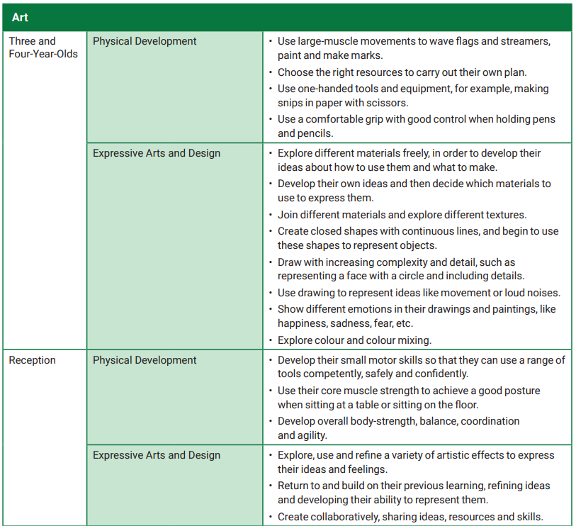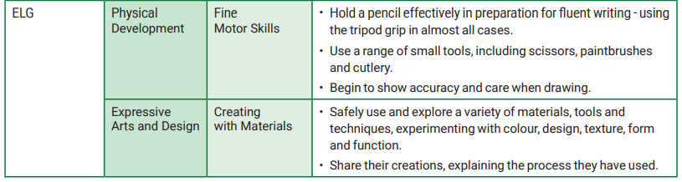
We achieve this through providing activities, both child and adult led, that promote creativity and experimentation in an artistic manner. Resources are always available within Continuous Provision. Also, within the EYFS classrooms, the following activities are some of what can be observed throughout the year:
- Scissor control and cut/stick activities
- Colour mixing in puddles outside
- Making large movements with a paintbrush on large rolls of paper
- Walks around the school grounds to appreciate our world and make observational drawings of what we can see
- Junk modelling
- Building sculptures with construction materials
- Observing what we can see in other artists work – thinking about how this makes us feel
- Nipping, flipping and gripping a pencil
- Singing and expressive dance

Creative Arts – Design and Technology
During Early Years Foundation Stage (EYFS), the essential building blocks of children’s design and technology capability are established. There are many opportunities for carrying out D&T-related activities in all areas of learning in the EYFS. By the end of the EYFS, we aim for the children to be able to: construct with a purpose in mind, using a variety of resources; use simple tools and techniques competently and appropriately; build and construct with a wide range of objects, selecting appropriate resources and adapting their work when necessary and select the tools and techniques they need to shape, assemble and join materials they are using. All of which form part of the Early Learning Goals that we aim towards:
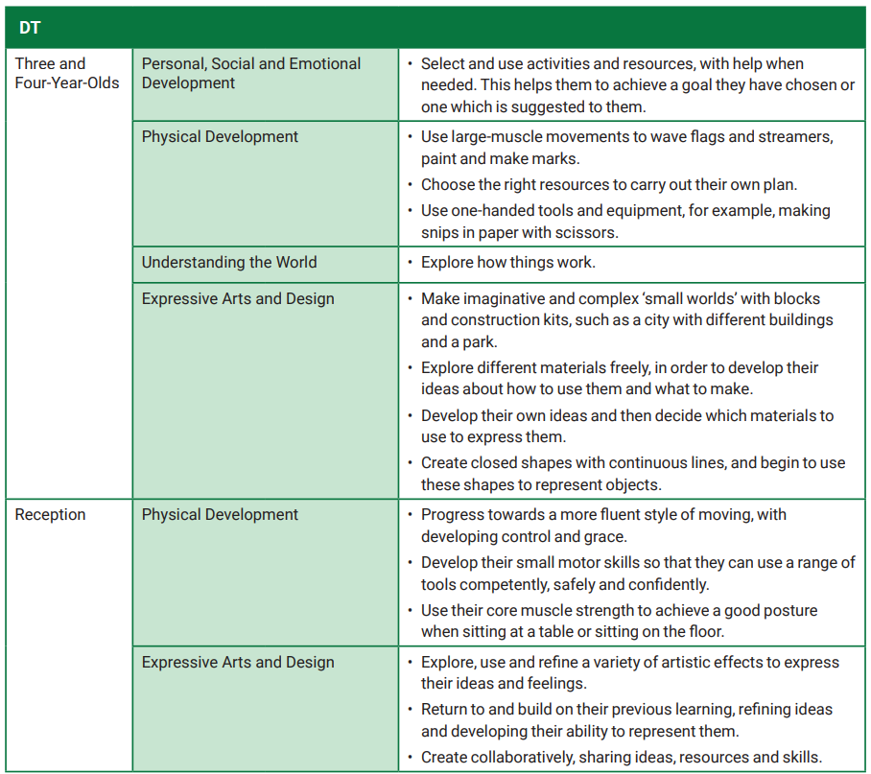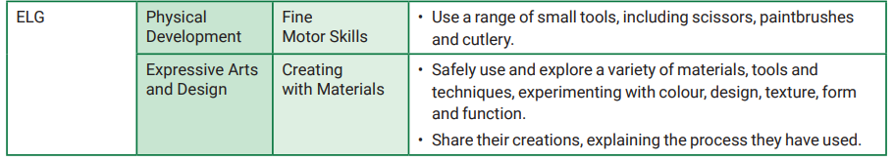
When supporting the learning of Design and Technology in Foundation Stage, we base our skills and knowledge on the following characteristics:
- Designing does not necessarily entail drawing
- Designing can mean using hand gestures, arranging and re-arranging materials and components, talking and listening
- Designing is usually intuitive
- The designing and making process is fluid
- Sometimes practical skills are taught directly
- Children have frequent opportunities to develop practical skills with a range of materials
- Children have frequent opportunities to explore construction kits
- Children have frequent opportunities to explore existing products
- Activities are appropriate to children’s prior experience
- Context is sometimes set by teacher, sometimes by the children
The children develop a sense of what the design process is and develop problem solving skills to achieve goals with the use of materials.

