EYFS Curriculum Statement
History
To ensure that our children in Foundation Stage come to understand their world and what has happened before in a meaningful way, we have thoughtfully weaved historical concepts through narrative, character and event as well as carefully chosen themes into our day-to-day learning. We select themes that are relevant to the children such as their history and growth from a baby to a child or family history, lifecycles and change over time, real life superheroes from the past and the development of toys over time.
We engage in activities that we record and look back on as memories from ‘before now’ to give the children a sense of the past and present. Past and Present is the Early Learning Goal that we provide opportunities throughout the year to develop the children’s skills and knowledge towards:
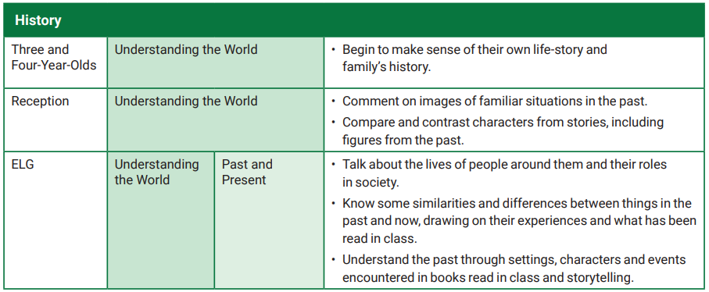
Within our Early Years Foundation Stage (EYFS) classrooms, the following are some of the activities or planned enhanced provision can be observed:
- Discussion about family photos uploaded to Tapestry from home
- Recording of events through photography, writing or drawing such as our Christmas Nativity to reflect back on
- Reading about inspirational people from the past as real-life superheroes such as Steven Hawking, Amelia Earhart, Queen Elizabeth and Grace Darling
- Learning about people who help us by hearing from people of different professions on Tapestry
- Reflecting on what we have read and the characters, setting and events
- Looking at family trees
- Exploring toys from the past and experimenting with how they work and their similarities and differences
The knowledge and skills that the children gain from their Foundation Stage year, then form an understanding of past and present that will allow them to continue to build their skill set as a historian in Key Stage One.

