EYFS Curriculum Statement
Religious Education
In Early Years Foundation Stage (EYFS), we support our children to learn about and learn from religious and spiritual insights, beliefs and practices. During the year, our children begin to explore the world of religion in terms, for example, of special people, books, times, places and objects, and visiting a place of worship (our local church).
In Foundation Stage, we:
- Celebrate the language and religion of children by encouraging the children to talk and introduce them to new vocabulary.
- Celebrate diversity by looking at religious artefacts to bring religion to life and inspire the children to question what they experience.
- Celebrate religion in our community by visiting our local church 3 times each year during Harvest, Christmas and Easter as well as discussing the other religious communities that engage in religious practise within our local area of Loughborough.
- Celebrate different faiths by exploring the diverse faiths of the children in our school and learning from them.
- Celebrate religion in our local environment by engaging in ‘wild worship’ when we appreciate the world around us.
- Celebrate religious stories by attending ‘open the book’ assemblies each week and reading from the bible in our classrooms. We also listen to stories from a range of faiths whilst we celebrate Diwali, Eid and Ramadan.
As part of our EYFS Framework, we work towards achieving the following goals:
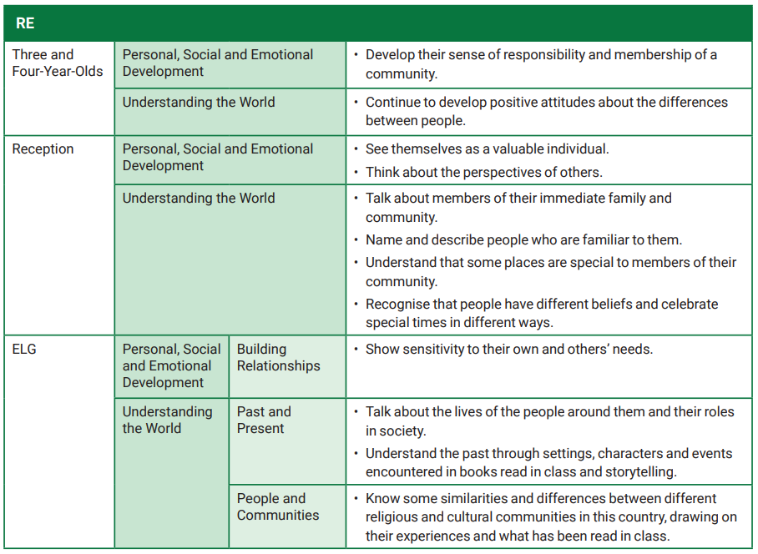
We provide the children with experiences that allow them to participate in family customs and routines both within our school as a Church of England Primary School but also within other faiths too such as following the customs of Chinese New Year. We also provide an understanding of diversity and uniqueness as well as the importance of having personal opinions and their own beliefs. We ensure that they feel valued as a member of our school but also a member of wider society. With this skill set and understanding, Foundation Stage Children then move into Key Stage One with a sense of belonging and confidence to talk in relation to religion.

