EYFS Curriculum Statement -Science
In Early Years Foundation Stage (EYFS), we investigate within all elements of our everyday learning. Science within our Foundation Stage is introduced indirectly through activities that encourage our children to explore, problem solve, observe, predict, think, make decisions and talk about the world around them. We call this developing an understanding of the world. Within the EYFS Framework, ‘Understanding the World’ is the main area that we work towards through gaining these skills but there are other areas of our Framework that also incorporate the need for scientific skills and knowledge:
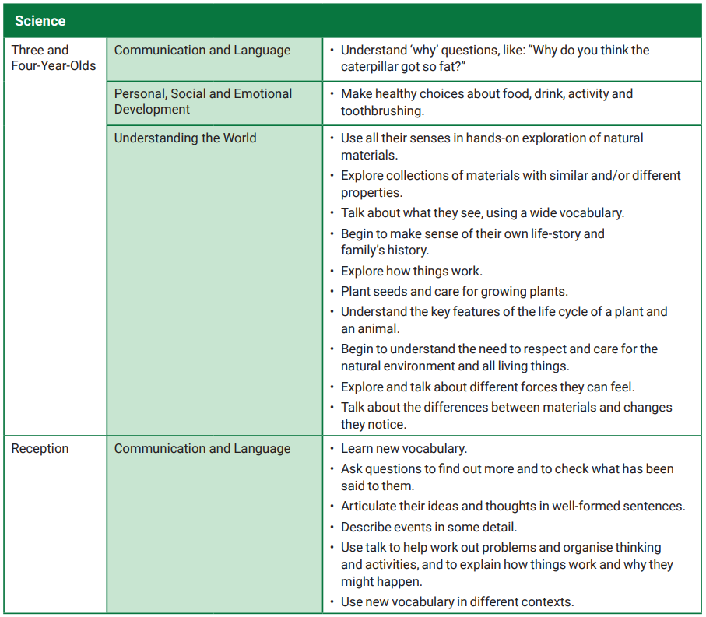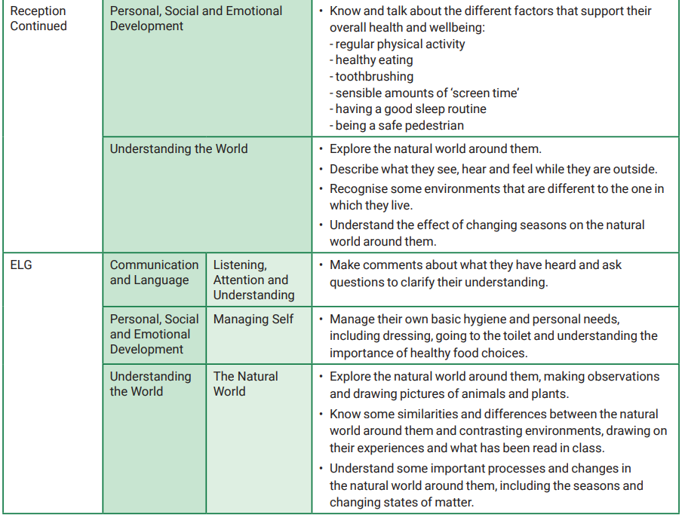

When in our Foundation Stage indoor and outdoor classrooms, children explore creatures, seasons, people, plants and objects in their natural environments. Our children observe and manipulate objects and materials to identify differences and similarities. For example, they may look at an egg whisk, sand, paper and water to learn about things that are natural and manmade and their different functions. Our children also learn to use their senses, feeling dough or listening to sounds in the environment, such as sirens or farm animals. Science skills and knowledge are learnt through all aspects of our play and are then developed through the support of adults to direct the children and their thoughts.
We encourage our children to ask questions about why things happen and how things work. We do activities such as increasing the incline of a slope to observe how fast a vehicle travels, or dissecting a plant to look at the different parts. We also ask the children questions about what they think will happen to help them communicate, plan, investigate, record and evaluate findings. We have an area dedicated to a weekly science experiment to allow the children use their natural curiosity to find out how things work and observe changes.
Each of the Enhanced provision or adult led activities designed support the children to become inquisitive learners who ask questions and use their senses to explore. This then provides a platform to develop their skills as a scientist as they progress into Key Stage One.

