EYFS Curriculum Statements
Computing
Despite computing not being explicitly mentioned within the Early Years Foundation Stage (EYFS) Framework, we provide many opportunities for our Foundation Stage children to use technology to solve problems and produce creative outcomes on a regular basis.
By the end of the EYFS, we aim for learners to know more about technologies and devices by regularly using them. Activities are planned to promote interactions to extend their existing knowledge of computing technologies. Accordingly, we use specifically targeted vocabulary and key words to support everyday learning such as: directional language, sequencing words, imperative - bossy words, algorithms and problem solving.
Within the Foundation Stage classrooms, the following skills and knowledge-based learning can be observed throughout the year:
- Devising a plan to solve how we move water from one space to another
- Writing instructions of how to plant a seed
- Following instructions including directional language
- Construction and deconstruction of objects
- Use of Code-a-pillars to create simple codes to move from one place to another
- Algorithms presented to children at an appropriate level dependent upon the child such as draw 3 circles using thick lines, thin lines and 3 colours
- Pictures being taken using an iPad
- Exploring old typewriters or mechanical toys
- Watching video clips
- Listening to music
All of the above, supporting the children to achieve their Early Learning Goals within the following areas:
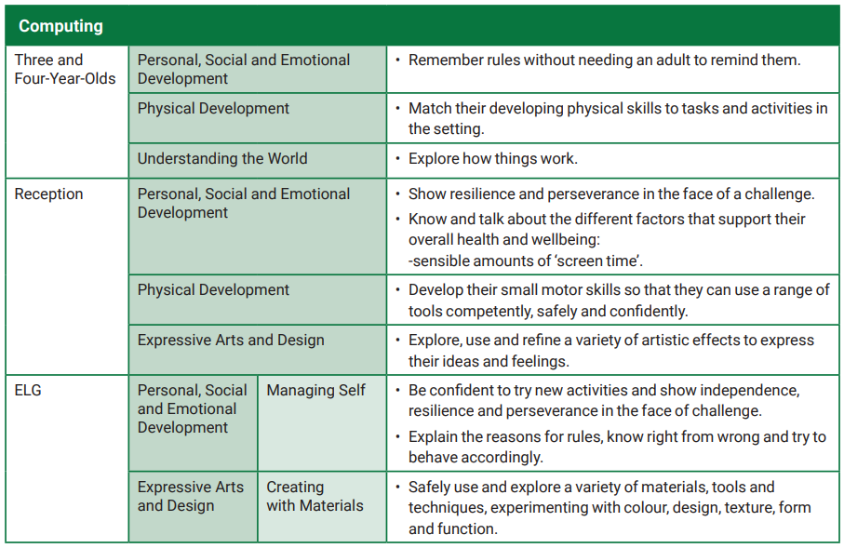
The Characteristics of Effective Teaching and Learning are also continually observed and assessed within each of the classrooms such as the children planning and thinking ahead, referring to visual aids to guide thinking, making independent choices, showing goal-directed behaviour and correcting mistakes, showing resilience and concentrating on things that are important. All of which are part of an essential skills set needed in preparation for learning of explicitly taught ICT from Year One onwards.
Creative Arts - Art
In Foundation Stage, our children communicate through their art making and demonstrate a natural curiosity to learn about different creative processes and techniques. This is evident through everyday learning and is apparent in all areas of learning throughout the classroom. We know the importance of nurturing and encouraging their innate curiosity. Art helps children to think through their ideas and to develop visual, spatial and tactile awareness, and investigative and manipulative skills. Children are taught to use their imagination by dismantling, combining and discarding ideas and materials. We introduce appropriate vocabulary to help the children to talk about what they have produced, what they like and how they can make improvements. We explore colours and colour mixing, mark marking including shapes, patterns and lines as well as textures and media.
As part of the Early Years Foundation Stage (EYFS) Framework, we support the children to achieve the following goals throughout the academic year:
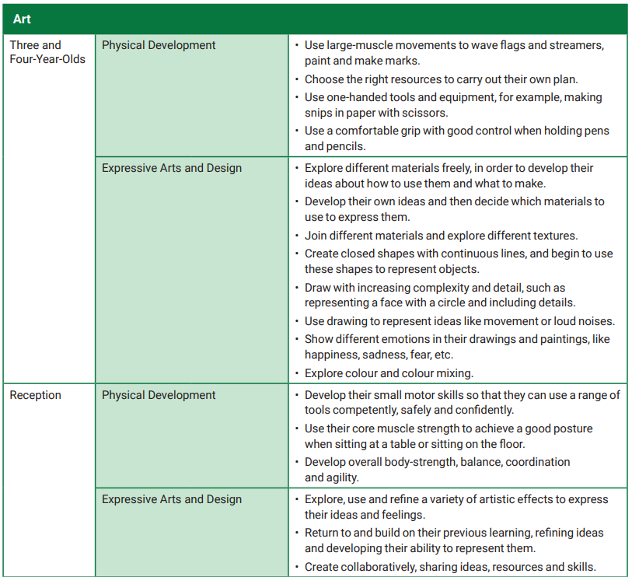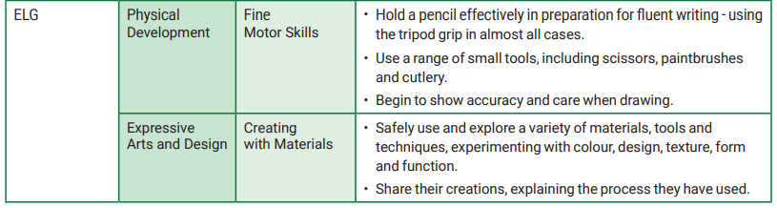
We achieve this through providing activities, both child and adult led, that promote creativity and experimentation in an artistic manner. Resources are always available within Continuous Provision. Also, within the EYFS classrooms, the following activities are some of what can be observed throughout the year:
- Scissor control and cut/stick activities
- Colour mixing in puddles outside
- Making large movements with a paintbrush on large rolls of paper
- Walks around the school grounds to appreciate our world and make observational drawings of what we can see
- Junk modelling
- Building sculptures with construction materials
- Observing what we can see in other artists work – thinking about how this makes us feel
- Nipping, flipping and gripping a pencil
- Singing and expressive dance

Creative Arts – Design and Technology
During Early Years Foundation Stage (EYFS), the essential building blocks of children’s design and technology capability are established. There are many opportunities for carrying out D&T-related activities in all areas of learning in the EYFS. By the end of the EYFS, we aim for the children to be able to: construct with a purpose in mind, using a variety of resources; use simple tools and techniques competently and appropriately; build and construct with a wide range of objects, selecting appropriate resources and adapting their work when necessary and select the tools and techniques they need to shape, assemble and join materials they are using. All of which form part of the Early Learning Goals that we aim towards:
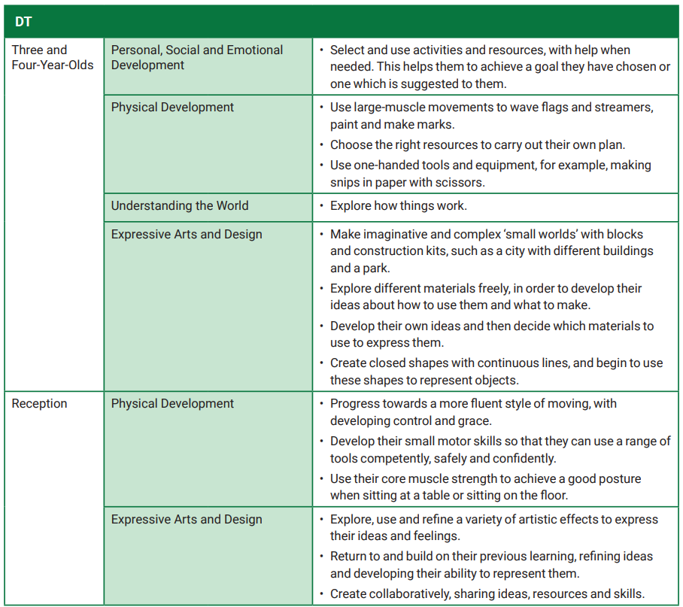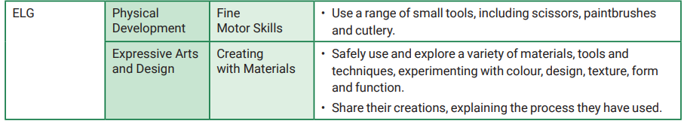
When supporting the learning of Design and Technology in Foundation Stage, we base our skills and knowledge on the following characteristics:
- Designing does not necessarily entail drawing
- Designing can mean using hand gestures, arranging and re-arranging materials and components, talking and listening
- Designing is usually intuitive
- The designing and making process is fluid
- Sometimes practical skills are taught directly
- Children have frequent opportunities to develop practical skills with a range of materials
- Children have frequent opportunities to explore construction kits
- Children have frequent opportunities to explore existing products
- Activities are appropriate to children’s prior experience
- Context is sometimes set by teacher, sometimes by the children
The children develop a sense of what the design process is and develop problem solving skills to achieve goals with the use of materials.
Geography
In Foundation Stage, we promote the opportunity for children to gain a wider experience of the world around them. The children learn, through first-hand experiences, how to explore, observe, problem solve, predict, think critically, make decisions and talk about the creatures, people, plants and objects in their natural environments. All of which are part of the essential skill set needed to then progress into the role of a ‘Geographer’ in Key Stage One.
The main focus within the subject of Geography in Foundation Stage is ‘Understanding the World’, one of our Early Learning Goals. We provide opportunities to reflect on events and routines that the children and their peers experience, but also provide opportunities to investigate similarities and differences that exist, introducing essential vocabulary including time and positional language. We explore the physical world within the local community and beyond. These experiences are both ‘first hand’ and ‘imaginary’ but will fundamentally be practical in nature and involve enriching vocabulary.
Examples of ‘first-hand’ or ‘sensory’ experiences that can be observed in our EYFS classrooms are:
- Walks around our local village of Quorn, including visits to the church or Cricket Pitch
- Exploring the school grounds in different weathers, seasons or times of the day, including for Forest School sessions
- Interacting with visitors of different professions/ hearing from people who help us via Tapestry
- Playing games that involve directional and map reading skills in Physical Education
Examples of ‘imaginary’ experiences that can be observed in our EYFS classrooms are:
- Role play, including small world play and loose parts
- Construction with a range of materials as well as sand, mud and water
- Exploration of what places and people are like through sharing stories and non-fiction books
All of the above contributes to supporting the children in both an adult led and child initiated manner for the children to achieve their Early Learning Goal of ‘Understanding the World’:
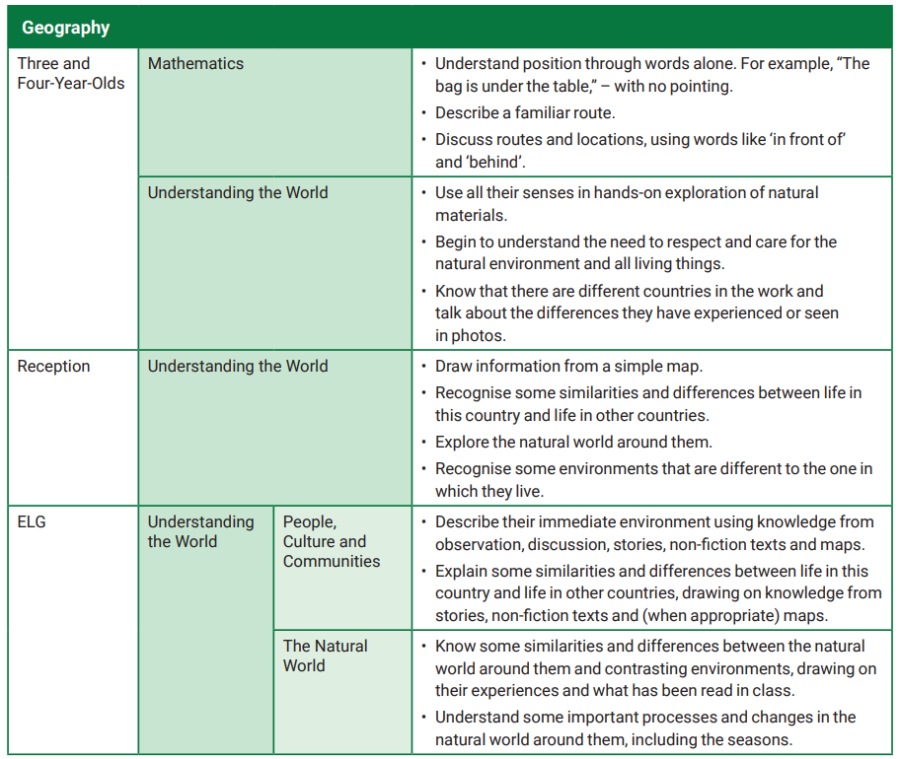

History
To ensure that our children in Foundation Stage come to understand their world and what has happened before in a meaningful way, we have thoughtfully weaved historical concepts through narrative, character and event as well as carefully chosen themes into our day-to-day learning. We select themes that are relevant to the children such as their history and growth from a baby to a child or family history, lifecycles and change over time, real life superheroes from the past and the development of toys over time.
We engage in activities that we record and look back on as memories from ‘before now’ to give the children a sense of the past and present. Past and Present is the Early Learning Goal that we provide opportunities throughout the year to develop the children’s skills and knowledge towards:
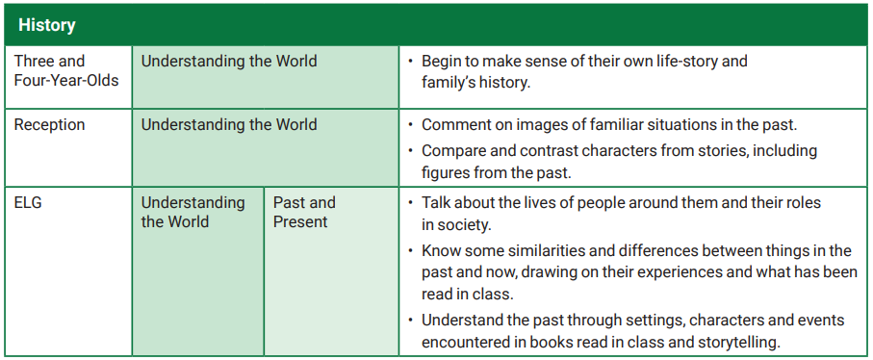
Within our Early Years Foundation Stage (EYFS) classrooms, the following are some of the activities or planned enhanced provision can be observed:
- Discussion about family photos uploaded to Tapestry from home
- Recording of events through photography, writing or drawing such as our Christmas Nativity to reflect back on
- Reading about inspirational people from the past as real-life superheroes such as Steven Hawking, Amelia Earhart, Queen Elizabeth and Grace Darling
- Learning about people who help us by hearing from people of different professions on Tapestry
- Reflecting on what we have read and the characters, setting and events
- Looking at family trees
- Exploring toys from the past and experimenting with how they work and their similarities and differences
The knowledge and skills that the children gain from their Foundation Stage year, then form an understanding of past and present that will allow them to continue to build their skill set as a historian in Key Stage One.

Modern Foreign Languages
Our main focus towards developing language skills in Early Years Foundation Stage (EYFS) is a focus upon Speaking and Listening as well as developing a sense of cultural awareness. Children in EYFS enjoy hearing different languages, listening to the flow and alternative sounds to those they hear in English, and they are fascinated by learning vocabulary for everyday items, including types of fruit and toys.
We explore different languages alongside topics such as Chinese New Year when we learn to say ‘Happy New Year’, ‘Hello’ and ‘Goodbye’. Staff members use their own experience from visiting different countries and from hosting individuals and families from different parts of the world to inform their knowledge. Through this, the attendance register is called using different languages and the children respond appropriately.
The children also enjoy learning about different customs which children in various countries experience, and they can compare them with our diverse customs in England. In this way, children can learn about Spanish or Dutch Christmas customs, and can compare them with our festivities during our annual trip to the church at Christmas time.

Music
Music is incorporated into all aspects of learning in Early Years Foundation Stage (EYFS). We listen to songs, sing and perform with expression daily through our continuous provision (resources that are always readily available to the children). Music and creative expression form essential parts of many of our Early Years Foundation Stage Framework:
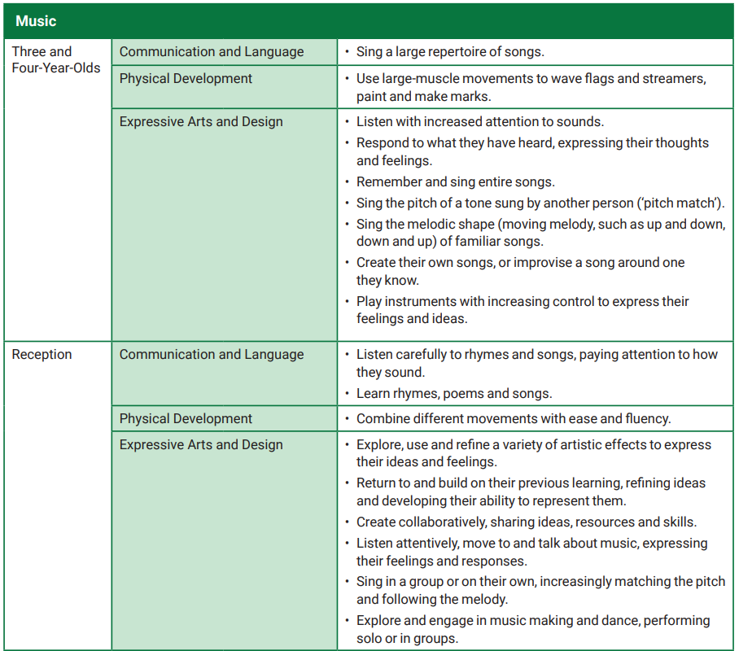
When in one of our Foundation Stage classrooms, the following are some of the learning opportunities provided that relate to music and expressive arts:
- Selecting a song from our ‘nursery rhyme bag’ to sing together
- Listening to music and discussing how it made us feel
- Learning new songs
- Matching pitch when following instructions throughout everyday routines
- Playing instruments and making our own band!
- Putting on a music concert for friends on the stage outside
- Performing during our church visits or within school such as our Nativity performance
- Creating rhythm by hitting different objects
- Matching sounds to characters in a story to reflect their role or personality/how they make us feel
These opportunities then provide a love of music and engaging in making sound to support the children when developing their skill set as a musician in Key Stage One.

Religious Education
In Early Years Foundation Stage (EYFS), we support our children to learn about and learn from religious and spiritual insights, beliefs and practices. During the year, our children begin to explore the world of religion in terms, for example, of special people, books, times, places and objects, and visiting a place of worship (our local church).
In Foundation Stage, we:
- Celebrate the language and religion of children by encouraging the children to talk and introduce them to new vocabulary.
- Celebrate diversity by looking at religious artefacts to bring religion to life and inspire the children to question what they experience.
- Celebrate religion in our community by visiting our local church 3 times each year during Harvest, Christmas and Easter as well as discussing the other religious communities that engage in religious practise within our local area of Loughborough.
- Celebrate different faiths by exploring the diverse faiths of the children in our school and learning from them.
- Celebrate religion in our local environment by engaging in ‘wild worship’ when we appreciate the world around us.
- Celebrate religious stories by attending ‘open the book’ assemblies each week and reading from the bible in our classrooms. We also listen to stories from a range of faiths whilst we celebrate Diwali, Eid and Ramadan.
As part of our EYFS Framework, we work towards achieving the following goals:
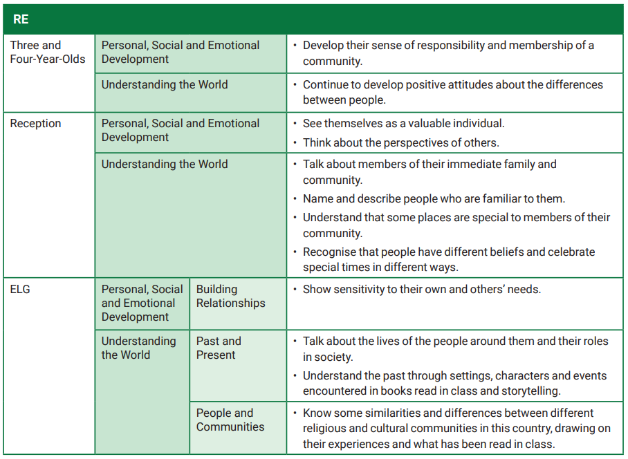
We provide the children with experiences that allow them to participate in family customs and routines both within our school as a Church of England Primary School but also within other faiths too such as following the customs of Chinese New Year. We also provide an understanding of diversity and uniqueness as well as the importance of having personal opinions and their own beliefs. We ensure that they feel valued as a member of our school but also a member of wider society. With this skill set and understanding, Foundation Stage Children then move into Key Stage One with a sense of belonging and confidence to talk in relation to religion.

Science
In Early Years Foundation Stage (EYFS), we investigate within all elements of our everyday learning. Science within our Foundation Stage is introduced indirectly through activities that encourage our children to explore, problem solve, observe, predict, think, make decisions and talk about the world around them. We call this developing an understanding of the world. Within the EYFS Framework, ‘Understanding the World’ is the main area that we work towards through gaining these skills but there are other areas of our Framework that also incorporate the need for scientific skills and knowledge:
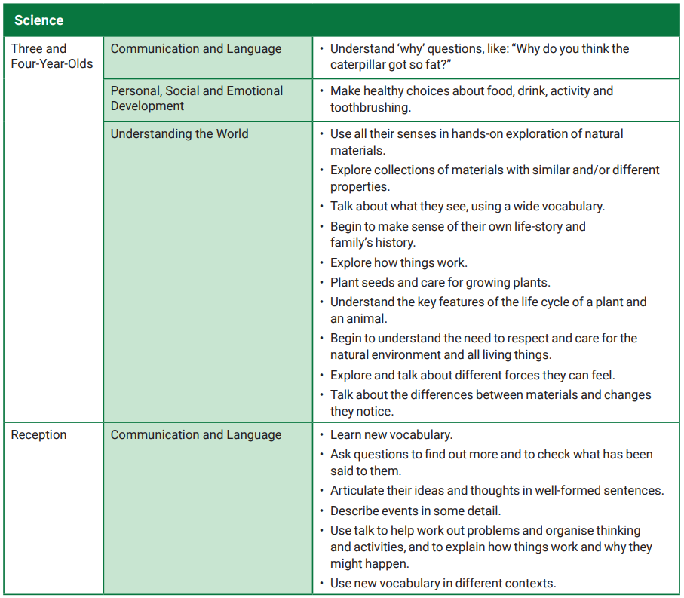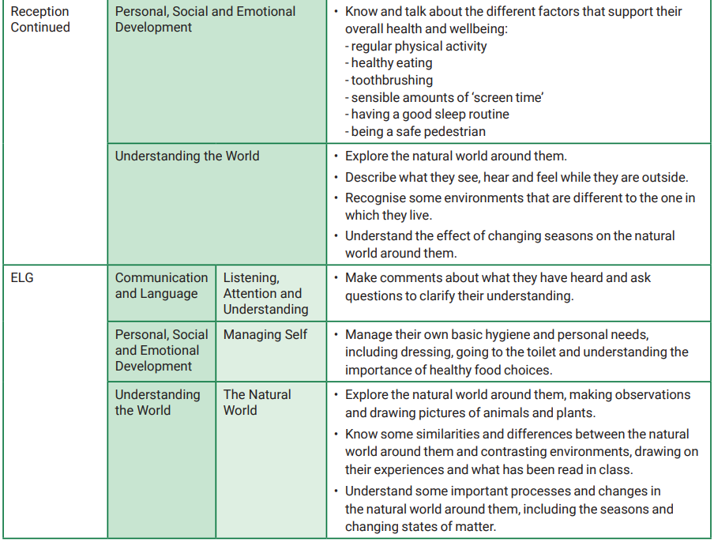

When in our Foundation Stage indoor and outdoor classrooms, children explore creatures, seasons, people, plants and objects in their natural environments. Our children observe and manipulate objects and materials to identify differences and similarities. For example, they may look at an egg whisk, sand, paper and water to learn about things that are natural and manmade and their different functions. Our children also learn to use their senses, feeling dough or listening to sounds in the environment, such as sirens or farm animals. Science skills and knowledge are learnt through all aspects of our play and are then developed through the support of adults to direct the children and their thoughts.
We encourage our children to ask questions about why things happen and how things work. We do activities such as increasing the incline of a slope to observe how fast a vehicle travels, or dissecting a plant to look at the different parts. We also ask the children questions about what they think will happen to help them communicate, plan, investigate, record and evaluate findings. We have an area dedicated to a weekly science experiment to allow the children use their natural curiosity to find out how things work and observe changes.
Each of the Enhanced provision or adult led activities designed support the children to become inquisitive learners who ask questions and use their senses to explore. This then provides a platform to develop their skills as a scientist as they progress into Key Stage One.

