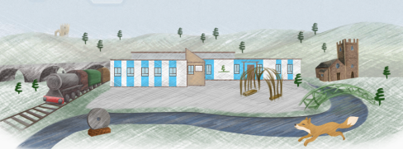
St Bartholomew’s C of E Primary School

Spring 2026 – PE Timetable

Children are to come to school in their PE kits (with the exception of Foundation Stage)
on the days of their PE lessons. These are as follows:

Class | Indoor PE | Outdoor PE
Foundation Stage | Friday | Friday
Yr1 Mrs Dixon & Mrs Collins | Monday | Thursday
Yr1 Mrs Hill | Monday | Thursday
Yr1 & 2 Mrs Wignall | Tuesday | Monday
Yr2 Miss Cronin | Tuesday | Wednesday
Yr2 Mrs Titchmarsh | Tuesday | Wednesday
Yr3 Miss Taylor & Mrs Marriott | Thursday | Tuesday
Yr3 Mr Applewhite | Tuesday | Wednesday
Yr3 & Yr4 Mrs Rowntree | Thursday | Tuesday
Yr4 Mr Wright | Monday | Thursday
Yr4 Mrs French & Mrs Campbell | Monday | Wednesday
Yr5 Mrs Schofield & Mrs Nel | Wednesday | Tuesday
Yr5 Mr Evans – Bolger | Wednesday | Tuesday
Yr5 & Yr6 Mr Codd | Thursday | Monday
Yr6 Mrs Spray | Wednesday | Monday
Yr6 Mrs Oakland & Miss Fielden | Thursday | Monday

Please note: If your child has an afterschool club on a non-PE day, please ensure they still come to school in their uniform and bring a change of clothes for their club.

Thank you for your support.

