Charnwood and Coalville Primary Partnership (CCPP)

What is CCPP? 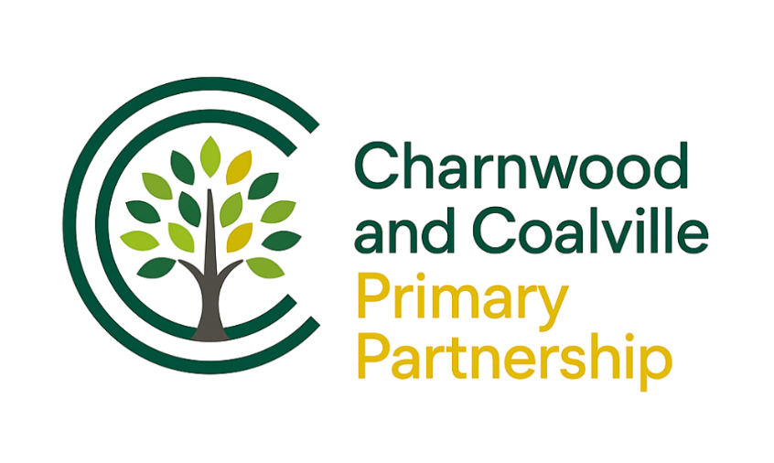

The Charnwood and Coalville Primary Partnership (CCPP) was formed in 2025 when Loughborough Primary Academy Partnership (LPAP) united with the Collaborative Partnership Charitable Trust (CPCT). Together, they created a diverse group of local primary schools committed to improving outcomes for children through collaboration and shared expertise.

The 14 schools within CCPP are: Burton on the Wolds Primary School, Cossington CE Primary School, Hall Orchard CE Primary School, Hathern CE Primary School, Holywell Primary School, Robert Bakewell Primary School, Stonebow Primary School, Quorn, St Bartholomew’s CE Primary School, All Saints CE Primary School, New Swannington Primary School, Thringstone Primary School, Warren Hills Community Primary School and Whitwick St John the Baptist CE Primary School.

What does CCPP do?

A key strength of CCPP is its quality assurance work. Headteachers work collaboratively to review standards across schools, including outcomes in the Foundation Stage, Key Stage 1 and Key Stage 2, as well as teaching and learning. This work provides professional challenge and support, leading to shared understanding and improvement. To add further rigour, external educational consultants, including a serving Ofsted inspector, support this quality assurance activity.

The work of the Headteachers is complemented by the School Business Managers’ group. Regular meetings provide professional support as schools operate within both maintained and academy finance systems and timelines. The group’s first major project has involved several schools working together to secure a new school food and payroll provider demonstrating the practical benefits of collaboration and shared decision-making.

In addition, CCPP supports a range of professional networks, including Foundation Stage and SEND groups. Curriculum development and training are enhanced through membership of the Professional Teaching Institute (PTi), with different subjects supported each term. These opportunities encourage staff at all levels to work together, share good practice and develop expertise for the benefit of children across all 14 schools.

Why is CCPP effective?

With 14 schools, CCPP is large enough to offer meaningful collaboration while remaining focused on the needs of children and staff. Strong professional relationships underpin a culture of trust, challenge and support, without becoming either too cosy or beaurocratic. This flexible partnership model has enabled schools to flourish together within a changing educational landscape, ultimately improving outcomes for children across the partnership.

