EYFS Curriculum Statement

Music
Music is incorporated into all aspects of learning in Early Years Foundation Stage (EYFS). We listen to songs, sing and perform with expression daily through our continuous provision (resources that are always readily available to the children). Music and creative expression form essential parts of many of our Early Years Foundation Stage Framework:
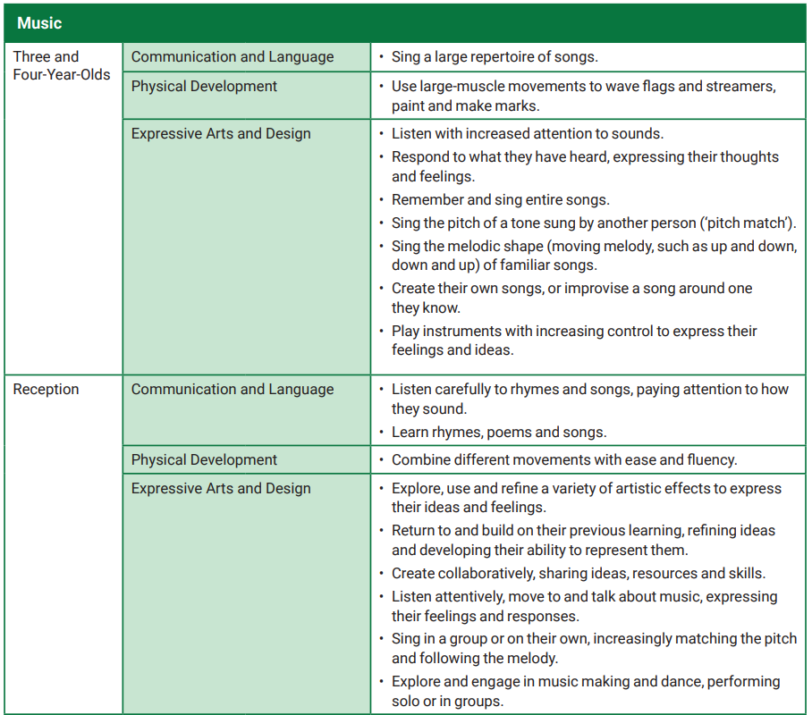
When in one of our Foundation Stage classrooms, the following are some of the learning opportunities provided that relate to music and expressive arts:
- Selecting a song from our ‘nursery rhyme bag’ to sing together
- Listening to music and discussing how it made us feel
- Learning new songs
- Matching pitch when following instructions throughout everyday routines
- Playing instruments and making our own band!
- Putting on a music concert for friends on the stage outside
- Performing during our church visits or within school such as our Nativity performance
- Creating rhythm by hitting different objects
- Matching sounds to characters in a story to reflect their role or personality/how they make us feel
These opportunities then provide a love of music and engaging in making sound to support the children when developing their skill set as a musician in Key Stage One.

