EYFS Curriculum Statement
Computing
Despite computing not being explicitly mentioned within the Early Years Foundation Stage (EYFS) Framework, we provide many opportunities for our Foundation Stage children to use technology to solve problems and produce creative outcomes on a regular basis.
By the end of the EYFS, we aim for learners to know more about technologies and devices by regularly using them. Activities are planned to promote interactions to extend their existing knowledge of computing technologies. Accordingly, we use specifically targeted vocabulary and key words to support everyday learning such as: directional language, sequencing words, imperative - bossy words, algorithms and problem solving.
Within the Foundation Stage classrooms, the following skills and knowledge-based learning can be observed throughout the year:
- Devising a plan to solve how we move water from one space to another
- Writing instructions of how to plant a seed
- Following instructions including directional language
- Construction and deconstruction of objects
- Use of Code-a-pillars to create simple codes to move from one place to another
- Algorithms presented to children at an appropriate level dependent upon the child such as draw 3 circles using thick lines, thin lines and 3 colours
- Pictures being taken using an iPad
- Exploring old typewriters or mechanical toys
- Watching video clips
- Listening to music
All of the above, supporting the children to achieve their Early Learning Goals within the following areas:
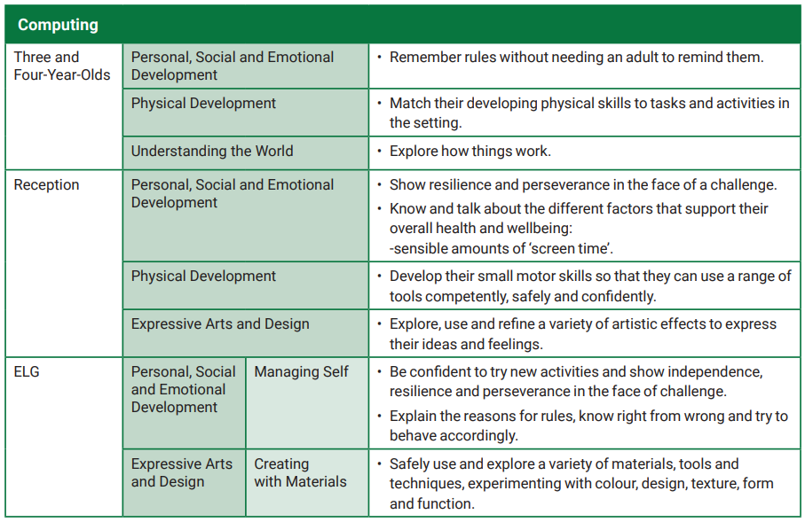
The Characteristics of Effective Teaching and Learning are also continually observed and assessed within each of the classrooms such as the children planning and thinking ahead, referring to visual aids to guide thinking, making independent choices, showing goal-directed behaviour and correcting mistakes, showing resilience and concentrating on things that are important. All of which are part of an essential skills set needed in preparation for learning of explicitly taught ICT from Year One onwards.

